The economic and social impact from City of Liverpool FC:
A preliminary assessment
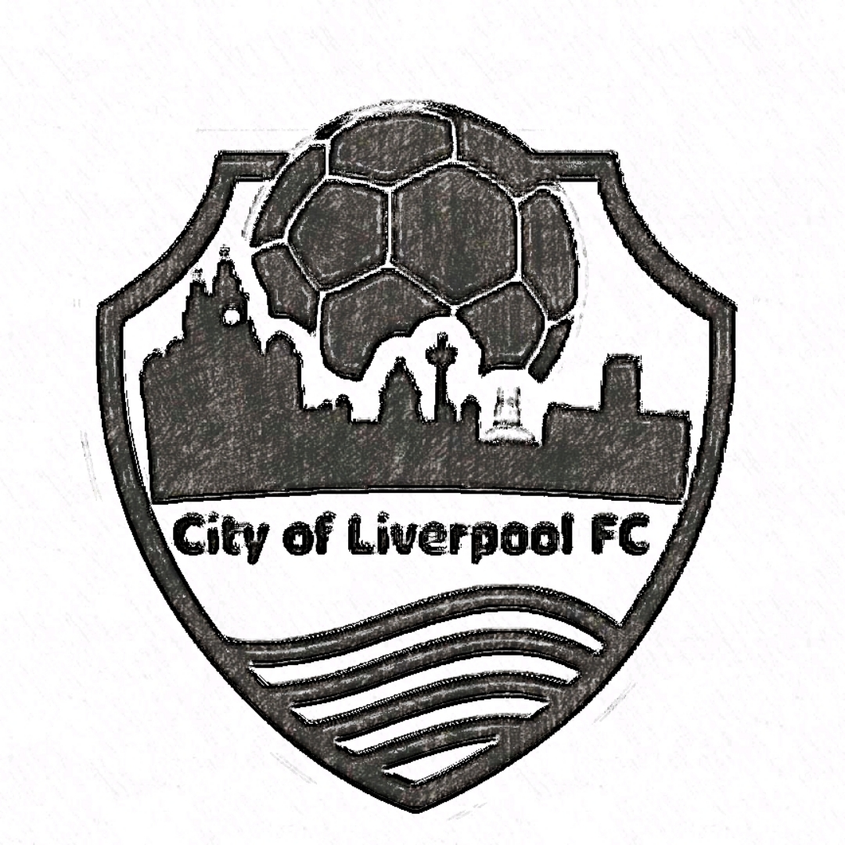

“We seek to be an inclusive footballing expression of our city region identity, community owned and operated and providing a foundation for grassroots football to thrive and grow”

Alan Southern
University of Liverpool

November 2019

1. Summary
City of Liverpool FC are a relatively new non-league football club currently playing in a stadium hosted by Bootle FC. Although not unique as a football club, the club is a social organisation, community-owned, in the Liverpool City Region. The Liverpool City Region is developing a supportive environment for local social organisations and it is important that City of Liverpool FC are well positioned to take advantage of the developing support system. In this context, we can offer an initial estimate of economic and social impact of the club, based their expenditure and a limited gathering of volunteer data.

- Expenditure by COLFC in the financial year up to end of May, 2018 was over £100,000.
- We estimate that this stimulated a further spending within the City Region of some £80,000 (see Figure 1).
- Volunteer hours per annum is estimated to be the equivalent of the club employing five or six full-time members of staff.
- At over 12,000 volunteer hours, this would equate to almost six people who would work a full 40-hour week over the course of the year.
- Or, expressed in terms of monetary value these hours are worth around £136,000 per annum, equating to around five full-time equivalent employees earning the UK average wage (see Figure 3).
- These figures give a baseline estimate of the economic and social value of City of Liverpool FC at around £320,000 (see Figure 4).

The officers of the club should consider the strategic importance of their social and economic impact. For this purpose, they should discuss how to capture more nuanced data that would increase the accuracy of these figures.

2. Introduction and Aims
This report is an independent piece of work conducted from the University of Liverpool. The aims of this report are to highlight the social and economic contribution of a community-owned non-league football club, the City of Liverpool FC. We show here a baseline estimate of impact and the potential from impact as the club (hereafter referred to as COLFC) develops and grows revenue, its range of activities and widens the supporter base. The report is not exhaustive but provides a starting point for COLFC to consider how it can develop to meet its mission and to show to interested parties the value of the work undertaken.

3. City of Liverpool FC
City of Liverpool FC was incorporated in January 2015 and as a community-owned cooperative non-league football club, they have depended on their membership and volunteers for all activities to date. COLFC were established to comply with the Cooperative and Community Benefit Societies Act 2014 and began their campaign to enter the non-league at Step 6. Success on the field came quickly and in their first season the club gained promotion and won two major cup finals. Further football success came and in the season 2018/19 when COLFC won the Hallmark Security League Premier Division meaning promotion into their current league, the Step 4 Northern Premier League North & West Division.

This success is underpinned by the club being commercially sustainable and expanding their community reach. They have played against former league clubs such as Chester in front of over 1,800 spectators and recorded their highest home league gate in September 2019, with almost 1,100 fans turning up for an FA Cup qualifying game against Warrington Town. Important to their start-up and early consolidation has been the ground share arrangement COLFC have with Bootle FC. This has enabled a substantive club presence in the Liverpool City Region and provided a focal point for the football, although of late it has limited the growth of COLFC in terms of facilities they can offer and revenue that could be generated.

Governance of the club is through seven officers, made up of six directors and a club secretary who report to the membership at an Annual General Meeting. Additional roles include Club Welfare Officer and Chairman of The Supporters Council. Volunteers provide continuous social media support including TV recording, fundraising and the ‘COLFC lotto’, supporter contacts, turnstile and gatehouse staffing on match days, hospitality, merchandise, website and graphic design, a statistician, junior volunteers, match day stewards and match day programme design and production. These additional volunteer roles have proven to be significant in the building up the social value of the club.

4. An Economic Profile of COLFC
In the financial reports for COLFC for the year ending May 2018, revenue was detailed at £107,000. This was up from the previous financial year of £58,000. For these two years expenditure ran at £104,000 in 2018, and £64,000 in 2017. In the seasons 2016/17 and 2017/18, COLFC drew in an aggregate attendance of over 22,000 for their home games. While the revenue generated from relatively high average home attendance is favourable, with an average of 471 in 2016/17, and 456 in 2017/18 (inclusive of cup competitions), the ground share arrangements mean that the broader economic benefit from this support has yet to be fully realised.

At the Special Annual General Meeting (AGM) held in the first part of 2019, COLFC Directors explained that growth would continue although so too would expenditure. Currently the club does not have any full-time staff, although part-time payments are made to player and coaching staff, with many day-to-day functions reliant on volunteers. Nearly all COLFC expenditure is focused on football matters. Around 50% of all spending is on player and coaching staff. Other significant costs include items such as ground share arrangements, training, kit and equipment, league fees, travel costs and football related fines issued by the league authorities. The growth demonstrated at the 2019 AGM displayed an increased expansion of activities by COLFC and began to show its economic potential as a community-owned asset.

The club secured major sponsorship in its early years and this helped facilitate its growth. In 2018 sponsorship accounted for around 30% of all revenue. The support provided by a local housing association, Regenda Homes, has proven to be highly significant to the club, with just less than two season left on the partnership arrangement with COLFC. The amount of revenue generated by sponsorship indicates two things: first, that the club is regarded by sponsors as a generator and conduit for social value. As a result, it seems that local organisations are keen to partner with COLFC. Second, the club do experience some risk and vulnerability by relying on a limited pool of sponsors for a large part of their annual revenue. Our previous work has shown how community businesses and social enterprises are often over dependent on a few sources for income. This tends to leave them searching for forms of finance that can support development while at the same time, they remain under capitalised.

5. A Social Profile of COLFC
COLFC have already built a strong social profile. The profile of the club is undoubtedly related to the club’s mission, set out as follows:

We seek to be an inclusive footballing expression of our city region identity, community owned and operated and providing a foundation for grassroots football to thrive and grow.

The club have integrated into its mission a local focus, responding to the need for accessible football in an inclusive way; trade and sponsorship is their main revenue generator, and they have built into their governance as a membership organisation, clear local accountability. As we look now, COLFC have developed a series of initiatives with significant local impact. In fact, the social profile of COLFC can be categorised as follows: facilitating local charity campaigns, football for social inclusion, and youth and grassroots football. We’ll look at each of these in turn.

COLFC and local charity
Over the course of the two seasons, 2016/17 and 2017/18, just under £20,000 was raised through COLFC supporting charitable initiatives, mainly during the match day. Typical of the activities the club attract on match days are bucket collections for local social organisations, such as junior football teams, from Huyton and Aintree for example. Collections have also been made for local food banks and the ‘Kits 4 Kids’ project, which donates football kits and football boots to local organisations.

Initiatives to donate coats, warm hats and gloves to local charities supporting children in the community have been organised. In December 2018 50 pairs of children’s pyjamas, 80 warm hats, 20 women’s winter jackets, 15 girls winter jackets, and 18 boys winter jackets were all donated. These campaigns support local families in low income communities.

COLFC and social inclusion
COLFC have widened their social footprint through their community-based initiatives. They have led on matters such as mental health support, wellbeing and were an early adopter in providing free sanitary care products on match days, advocating the ‘On the Ball’ initiative that many professional clubs now support. Their intention to promote a safe inclusive environment for people to enjoy football and play together in a non-competitive setting is a basis for their social impact. They see their use of football to:

- Make a positive impact on people’s lives across Liverpool, and
- Promote social inclusion and reduce social isolation for refugees and asylum seekers

Two areas of COLFC community work warrant greater attention: the initiative aimed at addressing the social exclusion of older men and that supporting the social inclusion of refugees in the wider Liverpool City Region.

Walking football is an initiative now supported by the FA, which has emerged to assist older men aged over 50, who have for various reasons become socially isolated. Research undertaken by London Sport has demonstrated clear physical, social and mental health benefits from walking football. This evaluation showed how walking football improved mental wellbeing through assisting memory and decision making, increased optimism, and generally thinking with clarity. It aided social wellbeing by developing social networks, feeling welcomed and sharing a common purpose. Walking football aids physical wellbeing by assisting breathing, increasing use of muscles and helping to overcome longer term health problems.
Liverpool City Region has been well documented for its health problems and the older male demographic is particularly problematic. It is this category of economically inactive older males that has often proven difficult to engage and walking football can be a clear aid to addressing this. COLFC walking football is run entirely by volunteers, is self-sustaining and is casually organised in the sense that it is open to all older males. The volunteers behind this initiative estimate an average turn out of 14 older men per week, over an elapsed period of the year that covers approximately 45 weeks.

COLFC refugee football is an initiative aimed directly at including those who have recently arrived in Liverpool City Region. However, one of the principles of this is to ensure that local young footballers are also involved to provide a mixed game of migrants/refugees and local players. Since its inception it is estimated that around 200 migrants/refugees have been involved and around 100 local players. Football boots and playing kit has also been supplied while should the need arise, COLFC volunteers help by making representation to the Home Office and provide references to assist refugee players who are seeking to achieve settled status. Given the political environment over the past few years, this initiative appears as a bold stance to defuse potential for racism.

COLFC, youth and grassroots football
The club have invested time and resource into supporting youth development and grassroots football. In March 2018, the Liverpool Football College announced a partnership with COLFC to turn out youth teams under the COLFC name from the beginning of the 2018/19 season. Liverpool Football College provides BTEC qualifications, from Level 1 to Level 3, in the topic of sport and sports administration. The link up for COLFC means they can provide opportunities for young players to find a route into the first team. It was stated at the time that the shared social values between the two organisations was a main reason for the partnership.

In 2016 the club sponsored the Edge Hill Junior Football League, a league running from under 7 years of age to under 12 years with around 70 teams involved. This developed so that at the beginning of the 2019/20 season, COLFC introduced their grassroots junior football. There are now thirteen teams playing in the city under the name of COLFC, many of which were new teams formed for this purpose.

The teams involved run from aged under 7’s to under 16s, Year 11, and play each weekend over the football season. This means that 13 junior teams train during the week and then play each weekend and involve just under 200 children in grassroots football over the course of their season. This initiative has come at a time when public expenditure cuts continue to impact on the price of junior football, with austerity induced difficulties meaning many community-based sports clubs have become unsustainable. These two initiatives by the club mean that football opportunities are provided for local people from six years of age onwards, right through to the first team.

Other areas to develop inclusive football are through women’s football and LBGT football. COLFC have made attempts in these areas, although have yet to consolidate their effort. Their early experiences of women’s football failed to be sustained, while in building close links to the local Mersey Marauders they have sought to support events such as ‘Football V Homophobia’ days. COLFC community work in these areas has potential although there are limits to what the club can achieve when wholly reliant on volunteers for development.

6. Measurements of Economic and Social Impact
COLFC are a community owned football club playing non-league football. Their economic impact reflects this, although their social impact appears to be in good health. The club will need to develop their own management of information to provide greater levels of accuracy in terms of its economic and social impact. However, we can provide an initial indication of impact as follows.

We can begin to assess the economic impact of COLFC by looking at three aspects: direct impact, indirect impact and induced impact. This would be referred to as their multiplier effect. Direct economic impact relates to the money spent by COLFC often referred to as a first-round effect from expenditure. Typical in the direct spending of a non-league football club would be expenditure on staff wages, spending with local businesses (for example on merchandise suppliers in Liverpool City Region), spending on businesses outside of the local area, and rents and rates. We believe in the case of COLFC that at least 50% of all their expenditure goes on staff wages.

Indirect economic impact is the subsequent effect from that first-round spending. This would be for instance, the spending undertaken by the players who live within the Liverpool City Region. For those who live outside, then their spending would ‘leak’ out from the locality. Each player living within the city region would spend with local businesses, spend with businesses outside of the area and pay rent and rates, just as the club would. Then there would be a further induced economic impact for example, due to the employees of the businesses that the player’s use spending their money in the Liverpool City Region on other businesses, rates and rents.

Figure 1 is a baseline assessment of the economic impact from COLFC. This estimate draws on several assumptions that for greater levels of accuracy, would require verification if better levels of information become available. Based on the assumptions made in Figure 1, we can estimate that COLFC has a local multiplier effect of 1.78. This would suggest that every £1 spent by the club would generate an additional spending within Liverpool City Region of 78 pence, or that the economic impact from COLFC from the 2018 financial year was £184,000.

Figure 1 COLFC local economic multiplier

Total revenue and expenditure in financial year ending May 2018:  Income £s  Expenditure £s  a) Direct spending by COLFC £s  b) Spending by COLFC in Liverpool City Region @ 55% of total £s  c) Indirect spending by COLFC staff, local businesses etc. @33% of total £s  d) Induced spending by local businesses and their employees etc. @ 25% of total £s | 107,495  103,553  103,553  56,954  18,795  4,699
Total economic impact from COLFC spending = (b+c+d) / a = 80,448 / 103,553
= 0.78

An estimated economic impact of £184,001

The above figures are a first baseline assessment. We know for instance, that if all players are local then at least 50% of COLFC spending will be localised. The first-round estimate of 55% is only slightly higher, while a third of local spending from those local businesses is consistent with similar studies in sports economic impact. We also assume that smaller businesses buy proportionately more locally than larger businesses, who would tend to buy at scale meaning increased volume, although more of which is likely to be beyond their local markets.

There have been a wide range of social impact audits that claim to assess the economic worth of social value. If we were to look at only one aspect of social value from the volunteering efforts of those involved in COLFC we can provide an indicative monetary value from this. Figures 2 and 3 provide an indicative example of the social value from COLFC volunteering.

Figure 2 The estimated hours of COLFC volunteering 2018/19

Officer and Volunteer Hours (Officer hours includes six Directors and Secretary)  Regular Officer Hours over the year @ 65 hours for 48 weeks  65 * 48  Additional Officer Hours per home game @ 35 hours for 25 weeks  35 * 25  Volunteer Hours per home game – 10 volunteers @ 5 hours for 25 weeks  (10 * 5) * 25  Additional Volunteer Hours for basic functions @ 30 hours for 48 weeks  30 * 48  Sub-Total Officer and Volunteer Hours per annum | Hours  3,120  875  1,250  1,440  6,685
Social Inclusion and Grassroots Volunteer Hours  Social inclusion football volunteers:  11 hours per week for 45 weeks over a year  11 * 45  Grassroots football volunteers:  13 junior teams each with two coaches including weekday training and weekend game hours at five hours per week over 40 weeks  ((13 * 2) *5) * 40  Sub-Total Social Inclusion and Grassroots Volunteer Hours | Hours  495  5,200  5,695
Total COLFC volunteer hours over the year | 12,380

The figures above provide an estimate of current volunteer hours at over 12,000 per annum. We can then use the hourly rate of the UK Living Wage at £9.30, and the ONS average weekly wage that works out at £12.70 per hour, to provide a calculation of monetary value. From this we can use the midpoint as the value of volunteering.

Figure 3 The estimated monetary value of COLFC volunteering

Citizens UK, the UK Living Wage is currently £9.30 per hour  12,380 * 9.3 = 115,134  Value of COLFC volunteering I £s  Average weekly wage per ONS is £508 / 40 = £12.70 per hour  12,380 * 12.70 =  Value of COLFC volunteering II £s | 115,134  157,226

These figures suggest an estimated value from COLFC volunteering of between £115,134 and £157,226, with a midpoint value of around £136,000. From this, we can use the figures as a baseline assessment of annual COLFC economic and social impact as set out in Figure 4.

Figure 4 Estimated economic and social value of COLFC

Economic Impact = £184,000
Social Impact of Volunteering = Midpoint figure (between 115,134 and 157,226) = £136,180

184,001 + 136,180 = 320,181

Baseline Figure of COLFC Economic and Social Impact = £320,181

By using the economic impact estimate and a midpoint figure for the value of volunteer hours, we can see in Figure 4 that an assessment of COLFC economic and social impact would amount to around £320,181 per annum based on their current commercial and social practice.

Other aspects of COLFC social value remain to be assessed. Their involvement in health and wellbeing initiatives can be accounted for with better information. We can see above, that some £10,000 per annum has been raised through charitable collections, while the actual effect on the involvement from participation in football by helping migrants/refugees assimilate into the Liverpool City Region, the engagement of younger people in grassroots football, or preventing ill or mental health problems among older males who play, would bring additional social impact. Each of these would increase the social value estimate of COLFC.

7. Building an Evidence Base
While some caution should be exercised in using the above figures, they do provide a baseline indication – in the absence of precise information being available – of COLFC impact. As COLFC expand in size and pursue on field success their economic and social impact will grow too. It is not likely that this will be an exponential growth and the more information that the club can capture then it is more likely that a greater level of accuracy can be attained in an assessment of economic and social impact. Organisations like Supporters Direct are keen to understand the social value of football, while there are a range of auditing tools to assist in this process. This can be an expensive process if not done with some forethought.

The officers of COLFC can now consider how they would like to evaluate their impact hereon. They can see that the club has an extensive social footprint, one that is expanding in an encouraging way since its inception. However, as a community organization, a community business no less, the club is vulnerable to many of the challenges facing those who work with excluded and disadvantaged groups and who are dependent on the work of volunteers. Building an evidence base to understand their social and economic impact in a more nuanced way would need to serve a clear set of objectives, be tied into the social mission of the club and importantly, be of practical use in developing the club.

The Liverpool City Region Metro Mayor’s Office and the Combined Authority are developing a strategic awareness of the social and economic value of social organisations. COLFC can be well positioned to take advantage of the support systems being put in place, such as additional forms of finance and investment. In this context, a useful next step would be an internal discussion on how to plan strategically for this purpose, and what type of data can be gathered to assess the club’s ongoing social and economic impact.

Brief bio of the author

Alan Southern is at the University of Liverpool, where he teaches and researches in the Management School. He is Principal Investigator into work on the social economy in Liverpool City Region (LCR) in the University’s Heseltine Institute for Public Policy, Practice and Place.

His recent work with colleagues has looked at the scale and scope of the social economy in LCR, the number of community businesses in LCR and what is needed in an industrial strategy in LCR. Previous work has included economic impact studies such as on European Capital of Culture, on Liverpool and Everton FC, Durham County Cricket Club, and the move by Arsenal from Highbury. He has edited and co-edited a number of books and published papers in this and similar fields.

Alan Southern can be contacted on: Alan.Southern@liverpool.ac.uk

COLFC Annual Accounts, May 2018.
Heap et al (2019) Growth, sustainability and purpose in the community business market in the Liverpool City Region, University of Liverpool Heseltine Institute and Power to Change.
London Sport Insight Team (2016) Walking Football Evaluation, London.
Various documents show this to be the case. See Parkinson et al (2017) The State of Liverpool City Region Report, or Labour Market Profile - Liverpool City Region available on Nomis (www.nomisweb.co.uk)
See Widdop et al (2017) Austerity, policy and sport participation in England, International Journal of Sport Policy and Politics, 10 (1) pp.7-24.
There are a wide range of available impact assessments from sport. See for example, Baade, R. A. and Dye, R (1990), The impact of stadiums and professional sports on metropolitan area development, Growth and Change, Spring, 21:2; Gelan, A. (2003). Local economic impacts: the British Open, Annals of Tourism Research, Vol. 30 (2); and Johnstone et al. (2000) The Midweek Match: Premiership Football and the Urban Economy, Local Economy, 2000, Vol. 15, No. 3.
See for example BLF, CLES and NEF (2009) Well-being evaluation tools: A ‘how to’ handbook, Developed for use as part of the Big Lottery Fund National Well-being Evaluation; McDonnell et al. (2012) ‘Measuring Change’, Community Evaluation Northern Ireland; NEF (2008) Local Wellbeing: Can We Measure It? New Economic Foundation: London.
See https://www.citizensuk.org/living_wage for Living Wage detail and see https://www.ons.gov.uk/ for average UK weekly wage.
Note the inconsistency of years in the calculations above.

